

**CAPE**

*Confédération africaine Coalition pour des Accords*

*des organisations de pêche artisanale de Pêche Equitables*

REPORT

*Side event*

*SMALL PELAGICS EXPLOITATION IN WEST AFRICA: SUSTAINABILITY AND FOOD SECURITY ISSUES*

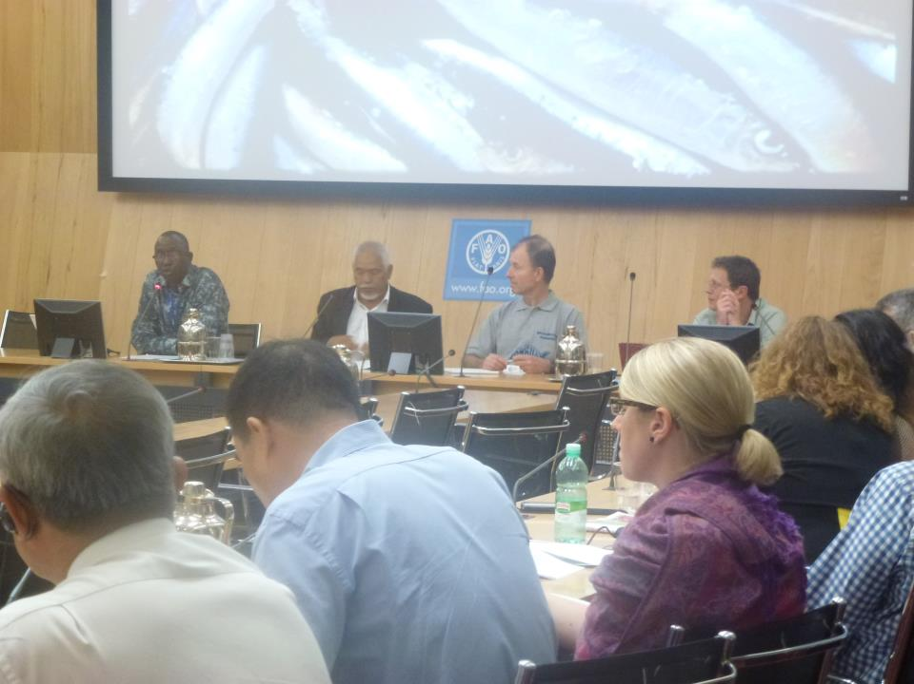

*FAO, COFI 30, Rome, 12 July 2012*

CAOPA CFFA – CAPE

email: [caopa.peche@gmail.com](mailto:caopa.peche@gmail.com) email: [cffa.cape@scarlet.be](mailto:cffa.cape@scarlet.be)

website: [www.cape-cffa.org](http://www.cape-cffa.org)

***Report on CFFA Participation***

***FAO Committee on Fisheries***

***- COFI 30 -***

The 30th session of the Committee on Fisheries (COFI 30) of FAO was held from the 9th until the 13th of July 2012, at the FAO headquarters in Roma. Nearly 540 participants assisted to the week’s discussions, including those from COFI member states, UN agencies, and intergovernmental and non-governmental organizations, and civil society groups. Highlights from the discussions are available at <http://www.fao.org/fishery/nems/40206/fr>

Besides plenary sessions, thematic side events were arranged by various organizations. Together with CAOPA, CFFA organized a side event on the 12th of July, on “Small pelagics exploitation in West Africa: sustainability and food security issues”.

The objective of this meeting was to have an overview of the situation of small pelagic fisheries in West Africa and their vital role for regional food security, both in terms of fish food supply for direct human consumption and as a source of livelihoods and income, highlighting the difficulties encountered in these last years.

As a matter of fact, of particular concern is the increase in investments and fishing intensity by distant water fishing fleets. These developments may be related to trends in small-pelagic fishing in Latin America, and also growing demand for small-pelagic as a source of fishmeal and fish oil, including for agriculture and aquaculture production.

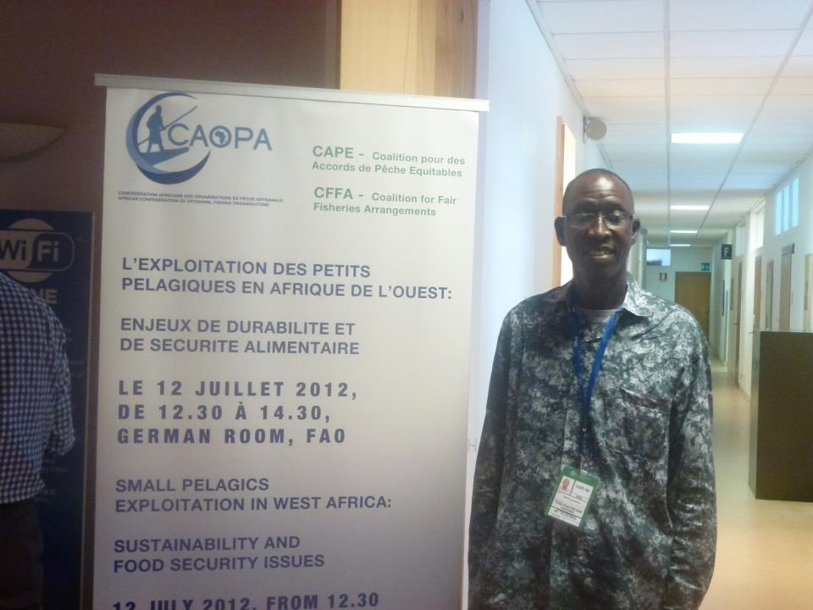

*CFFA CAOPA side event poster*

Chaired by Sid’ahmed Abeid (President of CAOPA), the meeting started with a statement by Gaoussou Gueye (General secretary CAOPA), highlighting the importance of small pelagics for West African fishing communities and their demands to FAO and its members (*Annex 1*).

|  |
| --- |
| **CAOPA demands to FAO and its members**  *Concerning the exploitation and the management of small pelagics in West Africa, CAOPA demands to FAO and its members:*   * To document better the impacts of the various types of exploitation of small pelagics on food security; * To recommend to states and regional fisheries organizations to consider the role of small pelagics in the ecosystems and in food security of developing countries populations when they are to make decisions for managing these resources and allocating access to these resources; * To support initiatives and efforts that will contribute to establish a concerted management of small pelagic resources in West Africa; * To support efforts by fishing communities to actively contribute to the management of these resources in a concerted and sustainable way; * To support an aquaculture based on species that do not require feed made from wild fish, that answers the demands of local and regional markets, and that is not contributing to the unsustainable exploitation of small pelagics stocks. |

This statement was followed by an analysis of the main developments affecting small pelagics exploitation in West Africa and policy issues arising, by Dr Andre Standing, from (TransparentSea / CFFA). (*Annex 2*).

After a short description of the trends in production and trade of small pelagic, some recent developments (2010-2012) which can have a negative impact on food security in West Africa, were examined:

* The return of former Soviet Union ‘super trawlers’ to Senegal;
* The new fisheries agreement between Chinese *Poly Hondone Company* and Mauritania;
* The expansion of fishing and fish trade by *Pacific Andes group* in West Africa.

Various factors influencing expanding investments and industrial fishing in West Africa’s small-pelagics were presented:

* Links with industrial aquaculture (production of fish oil and fish meal);
* Overcapitalization and decreasing profitability of global Distant water fishing fleets targeting small pelagic;
* The growth of China’s overseas fishing sector.

Some key considerations were then presented, particularly on the need to have better information on the catches and trade trends for small pelagic (including for the artisanal products trade), and to have further clarification on measures taken by fisheries authorities for achieving sustainable fishing for small pelagic, particularly for regulating access for the large ‘super trawlers’ operating in the region.

A final presentation was made by Brian O’Riordan (ICSF), on the main factors that have affected the small pelagic exploitation by super trawlers in South Pacific, based on a case study of the over-exploited jack mackerel, and the implications it may have for West Africa, with the arrival of these fleets in the region *(Annex 3*).

Several key questions, echoing the demands of CAOPA, and taking into accounts issues raised during the presentations, were proposed for the debate:

* How can we pursue policies that maintain or even increase the supply of small-pelagics for direct human consumption in West Africa?
* How can we pursue policies that prioritize access for small-scale fishers and fish production systems in the small-pelagic sector?
* As a straddling or migratory stock of fish species, how can West African countries develop better regional management of small-pelagics?
* How can the small-scale sector, including women in the post harvest sector, be better integrated into policy-making discussions, including in the small-pelagics sector?

It emerged from the debate, facilitated by Dawda Saine (CAOPA) that small scale fishery is a key issues for West African countries present. Priority should be given to fishing for direct human consumption, and this should be recognized by FAO.

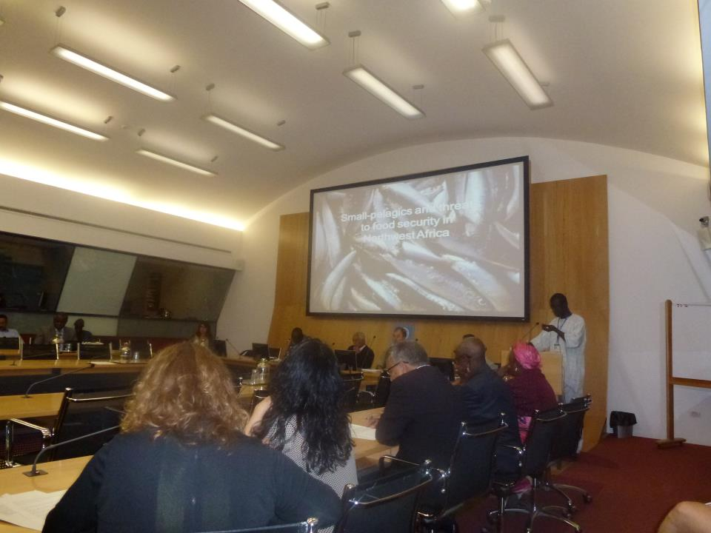

*Side event debate*

The fact that small pelagic fisheries are unpredictable was also underlined, in particular taking into account the climate change issue; the *upwelling* fluctuates from a year to another, which causes a great variation of the stocks.

The communication of fishing and trade data concerning small pelagic should be improved because, currently, they are not reliable. Administration and civil society should be mobilized to that end, and better cooperate for management of the small pelagic.

Moreover, sub-regional and regional cooperation between all the sectors should be encouraged (research, administration, professionals…) for the management of these species, most of which have reached their maximum sustainable yield. The increasing role of the SRFC was underlined.

A proposition was made for the creation of a fund to be used for the management of small pelagic in the sub-region. The important role of CSOs and CAOPA was underlined and it was suggested that their field of action should be reinforced and broadened (ex. The fisheries policy of the African Union is based on an active participation of CSOs such as CAOPA).

The side event was attended by 58 persons, with representatives from 12 FAO members delegations (Senegal, Mauritania, Ivory Coast, Morocco, EU, Russian Federation, Spain, Portugal, Germany (GIZ),Venezuela, Colombia, Algeria) and several Intergovernmental organisations (CECAF, SRFC, COMHAFAT, etc).

|  |
| --- |
| **A first encouraging step**  At the COFI plenary session that followed the side event, a request was made by Senegal and the European Union for FAO to put as a work programme priority, the further studying of the impact of industrial exploitation of species low down the food web (i.e. including small pelagics).  Senegal particularly emphasized the importance of small pelagics for food security and livelihoods of West African coastal populations. |

**Annex 1**

*STRATEGIC IMPORTANCE OF SMALL PELAGICS*

*IN WEST AFRICA*

*GAOUSSOU GUEYE, GENERAL SECRETARY CAOPA*

Rome, the 12 July 2012

*Confédération africaine des organisations de pêche artisanale*

*African Confederation of Artisanal Fishing organisations*

|  |
| --- |
| *STRATEGIC IMPORTANCE OF SMALL PELAGIC*  *IN WEST AFRICA* |

*PRESENTATION, GAOUSSOU GUEYE, GENERAL SECRETARY CAOPA*

Contact:[gaoussoug@gmail.com](mailto:gaoussoug@gmail.com)

Ladies and Gentlemen, Dear Colleagues,

At this very moment, with the economic crisis severely affecting our African countries, our small pelagic resources have become of even greater strategic importance for food security. The sardinellas that we fish provide proteins and other nutrients at affordable prices to the most disadvantaged groups of the population.

At this very moment, drought and desertification are gaining ground in West Africa, and our sardinellas help many of our farmers to survive in difficult times. It plays an important role to fight poverty in all rural communities, even those who live far away from the sea.

For those who live with and from the sea, our fishing communities, small pelagics provide numerous jobs: from the fisher to the fish processors and fishmongers. It is mostly artisanal fisheries processed products that feed the regional fish trade although in some countries, like Ghana or Nigeria, catches of industrial fisheries also supply the local market significantly.

Working conditions are hard, especially for women fish smokers who must inhale smoke from before sunrise to well after sunset for years, and support is needed to improve their working conditions.

As you see, Sardinella, it's our life blood, but it is also 'the fish of the poor and our 'food safety net'.

In its resolution on sustainable fisheries adopted in 2011, the UN General Assembly expresses ‘its awareness of the importance for food security and ecosystems, of marine species lower down the food web’, such as small pelagics. In order to ensure the sustainability of these resources in the long term, the Assembly calls on the States, ‘either directly or through sub-regional agencies or arrangements, regional or global bodies, to analyze the impact of fishing on these resources’.

**We, the African artisanal fisheries professionals from CAOPA, can only give our support to this resolution, and we would like the FAO to document better the impacts of the various types of exploitation of small pelagics on food security.**

Indeed, today, some of our small pelagic resources, and our food security, may be in danger. The number of factory trawlers that exploit our small pelagics is increasing. Some of them we can see from far, as they are over 120 m long. Their activities are increasing further the pressure on stocks, particularly on our sardinella, which is showing signs of overexploitation.

These ships also pose serious threats to ecosystems, as the fishing gears they use are not selective and take large amounts of bycatch, including sharks and rays, sea turtles, as well as large quantities of the demersal fish we, the artisanal fishermen, also target.

Secondly, we must also consider that small pelagic fish are the basis of the food chain - if small pelagic fish stocks decline, many other species that feed on them, including species targeted by artisanal fishers, will decline as well.

An element that makes things even more difficult is the fact that catches from our sector are probably underestimated, which may lead some to think there is a large surplus that can be caught by foreign fleets. . Some scientific projects are trying to reconstruct more accurate catch data, showing the true importance of artisanal fisheries, and this is to be encouraged.

What we need today is the transparent application of limits on catches of small pelagic fish, and also the application of clear access rules.

When allocating access, we should not treat in the same way a fishery that is intended for direct human consumption, and a fishery that is intended to produce fishmeal to feed livestock or farmed fish, especially when there may be competition between these two types of operations. Priority access should go to those who fish for direct human consumption. Another criteria could be to give priority access to those using selective fishing gears, in order to avoid by catch and to protect ecosystems.

**We, the African artisanal fisheries professionals from CAOPA, ask FAO to recommend to states and regional fisheries organizations to consider the role of small pelagics in the ecosystems and in food security of developing countries populations when they are to make decisions for managing these resources and allocating access to these resources.**

In general, it is necessary for the governments, industry and civil society of our countries to have a clear idea of which fleets are fishing in our waters, what they fish and how much, to be sure that this will not lead to overexploitation of our resources. As sardinellas are moving between our countries, we believe that our countries should move towards a concerted management of small pelagics, taking into account environmental aspects, but also the necessity to supply local and regional markets.

**We, the African artisanal fisheries professionals from CAOPA, feel the FAO should support initiatives and efforts that will contribute to establish a concerted management of small pelagic resources in West Africa.**

On the other hand, the sector’s participation is essential for sustainable management of shared small pelagic resources. CAOPA members are deeply engaged in this direction.

I would like to take the example of the fishing agreement between Senegal and Mauritania, which for many years, is allowing Senegalese artisanal fleet to get nearly 300 fishing licenses to catch small pelagics in Mauritanian waters. Since 2008, artisanal fishing organisations from Senegal and Mauritania have partnered to promote sustainable artisanal small pelagics fisheries.

The role of professionals in these negotiations, now recognized by our respective governments, is to facilitate the negotiation, execution and monitoring of the fisheries agreement protocol between the two countries. These efforts led in particular to the establishment of a joint committee made up of professionals for monitoring the implementation of the agreement, particularly in terms of landings and marketing, resolving potential conflicts and discuss improvements. This experience could be replicated in other countries where people are fishing on shared stocks.

**We, the African artisanal fisheries professionals from CAOPA, call on the FAO to also support these efforts by fishing communities, to actively contribute to the management of these resources in a concerted and sustainable way.**

Finally, I wanted to address the issue of the interaction between aquaculture development and exploitation of small pelagics. We agree that it is important to develop aquaculture in Africa, but above all it must be done from the perspective of improving food security for African people. It is not a solution to develop an aquaculture that requires the exploitation of wild stocks of small pelagic fish as its feed source, particularly where these show signs of overexploitation and which are, themselves, a central element to ensure that food security.

**What we need is an aquaculture based on species that do not require feed made from wild fish, that answers the demands of local and regional markets, and that is not contributing to the unsustainable exploitation of our small pelagic stocks. We, the African artisanal fisheries professionals from CAOPA, ask this to be taken into account by the FAO and its members when planning and supporting aquaculture development around the world.**

**Annex 2**

*FOOD SECURITY AND NORTHWEST AFRICA’S SMALL-PELAGIC FISHERIES*

*DR ANDRE STANDING, TRANSPARENTSEA / CFFA*

**FOOD SECURITY AND NORTHWEST AFRICA’S SMALL-PELAGIC FISHERIES**

Dr André Standing, TransparentSea / CFFA

1. Small pelagics that are found in great abundance off Northwestern Africa play a critical role in food security in this region. They are fish species that are the staple fish-food consumption throughout West Africa, particularly as demersal species have gained higher value through export markets and have decreased in abundance. In Senegal consumption of small pelagic species, primarily sardinellas, represents nearly 75% of the overall domestic fish consumption. The aim of this short report is to inform a side meeting at this year’s COFI on the theme of food security and small-pelagic fisheries off Northwest Africa. Here we briefly describe trends in production and trade in small-pelagics, we reflect on some recent developments in the sector, which may be having a negative impact on food security, and we highlight some key research questions and policy considerations that will inform ongoing work by CAOPA and CFFA.

## A] PRODUCTION AND TRADE

2. Patterns of production, trade and consumption of small-pelagic fish in Western Africa are complex and dynamic. One can distinguish between two distinct, but interrelated sectors – the small-scale sector which catches small-pelagics almost exclusively for local and regional consumption, and the industrial sector, comprising both nationally owned industrial boats and distant water fishing fleets, which supplies both West African and international markets.

3. Published data on the total catches and trade from the small-scale sector are varied and lack consistency, with most studies recognizing that official data is unreliable and tends to under estimate the extent of production and trade. In Northwest Africa, the fleet of small-scale fishers from Senegal are clearly the most numerous and productive; there are aprroximately 59,000 Senegalese small-scale fisher and small-pelagics make up about 70% of their catch, or 430,000 tonnes in 2005.[1] This in turn supplies fish for the post harvest sector that employs an estimated 41,000 people, over 90% of whom are women. Mauritania has a much smaller artisanal sector that landed about 19,000 in 2005 increasing to nearly 60,000 by 2010. But almost all of this catch by the small-scale sector is consumed in local markets, or is processed and traded regionally. One study in 2005 estimated that half the catch of sardinellas, the most abundant species of small-pelagics in the region, are sold in Senegal, Mauritania and the Gambia, while the other half is traded to other West African countries, with trade circuits stretching as far as Gabon in central Africa. [2]

3. Alongside this small-scale production system is the industrial sector, which is concentrated in Mauritania with annual catches of small-pelagics fluctuating from about 560,000 to over 800,000 tonnes.[3] Until the early 1990s industrial fishing for small-pelagics in West Africa was dominated by vessels from the Soviet Union, but with the collapse of the Soviet Union during the 1990s, their numbers in West Africa temporarily declined, to be replaced by an increasing number of European boats, particularly from the Netherlands, Lithuania, Latvia, Poland and Ireland, who began fishing under an EU fisheries agreement in Mauritania in 1996. The current EU FPA in Mauritania limits the number of fishing vessels targeting small-pelagics to 20, with a total allowable catch of up to 300,000 tonnes.

4. Russian small-pelagic trawlers ended fishing in Senegal by 1999, however many former Soviet Union boats have passed ownership to private companies based in Russia and Eastern Europe and have continued to fish, under various flags, through free licenses and charter arrangements in Mauritania. It is likely that many of these former ex-Soviet boats make up the bulk of the small-pelagic Distant Water Fishing Fleet (DWFF) operating in Mauritania today, which number about 50. Table 1 details the flag states of pelagic trawlers operating in Mauritania under charter arrangements and private licenses. In addition to this DWFF, are nationally owned trawlers that originate mostly from China. Total catch of small-pelagics from the national fishing fleet in Mauritania is reportedly quite small, being in the order of 20,000 tonnes, half of which is processed in Mauritania for fishmeal.[4]

5. The growth in European trawling for African small-pelagics increased imports of African small-pelagics to West Africa - unlike the Soviet Union trawlers that exported comparatively little of its catch to West Africa, the Dutch trawlers in particular expanded export of small-pelagics caught in West Africa to African markets, with Nigeria being the most important. Nigeria’s supply of small-pelagics from industrial fisheries therefore grew impressively since the end of the 1990s, nearly doubling from 1993 to 1998, almost all of which originated from Dutch companies. Nigeria is the now the largest West African market for small-pelagics by far, with total imports being roughly 600,000 tonnes per year.[5]

**Table 1: Small-pelagic DWFF (excluding EU trawlers fishing under EU FPA).**

|  |  |  |  |
| --- | --- | --- | --- |
| Charter arrangements | | Private Licenses | |
| Russia | 7 | Belize | 17 |
| Ukraine | 1 | Russian | 7 |
| Comoros | 1 | St. Vincent and Grenada | 4 |
|  |  | Ukraine | 4 |
|  |  | St. Kitts and Nevis | 3 |
|  |  | Comoros | 3 |
|  |  | Georgia | 1 |
|  |  | Guinea | 1 |
|  |  | Peru | 1 |

Source: *ex post* evaluation of EU FPA, 2011.

6. It should be noted, however, that there is no accurate publically available data on the trade dynamics for the majority of industrially caught small-pelagics from Northwest Africa. A recent FAO Working group report on the status of small-pelagic fish stocks off Northwest Africa states that the main processing plant in Mauritania supplies frozen fish for Eastern European markets, and previous research has suggested the majority of catches by the DWFF are landed directly in Las Palmas and then end up being sold in Europe, Asia, North Africa and West Africa, but how much goes where is poorly documented.

## B] STATUS OF THE STOCK

7. Stock assessments for small-pelagic fish in Northwest Africa have been undertaken for several decades, including by national research institutes in Senegal and Mauritania, acoustic surveys by Soviet Union and Norway research vessels, and more recently compilation and analysis of various data by a working group established by the FAO. A key finding of this combined research is that the abundance of small-pelagics in the region is highly influenced by climatic variations that alter the ‘upwelling’ of the North Atlantic sea. Stocks of small-pelagics therefore vary considerably from year to year, with some concern that global climate change will lead to increased volatility and potentially decreased biomass.

8. Recent evidence also strongly shows that several of the main commercially caught small-pelagic species have been overfished. The FAO’s working group has recommended decreasing fishing effort for some species, while not allowing further increases in fishing effort in others.[6] There is particular concern with rates of overfishing of sardinella, the main species caught by the small-sector and traded regionally, with recommendations that the total catch for the three subspecies of sardinella should not exceed 660,000 tonnes. In 2009, total catches in the region were estimated at 1,268,000 tonnes.

## C] 2010-2012: RECENT DEVELOPMENTS IN THE INDUSTRIAL SECTOR

9. Over the last 2-3 years there appears to be some important developments in industrial fishing and fishing investments in North West Africa’s small-pelagics. These increase concern with the sustainability of stocks, which in turn could have significant implications for the small-scale sector and fish food availability. 3 events can be highlighted:

*i) The return of former Soviet Union ‘super trawlers’ to Senegal.*

10. In 2010 reports emerged from Senegal that several ‘super trawlers’ were fishing for small-pelagics in the Senegalese EEZ. By 2012, amid widespread protest by local fishing organisations, it was revealed that about 30 foreign trawlers had been issued with temporary licenses to fish small-pelagics over a two year period. The impact of this on the stocks of small-pelagics is yet to be determined, but reports from Senegal suggest a marked decline in local catches and decreased availability of fish for local processing and domestic and regional trade.

11. These events suggest that part of the DWFF operating in Mauritania have extended their fishing operations Southwards to Senegal. This may have been facilitated by a Russian-Senegal military pact signed in 2007, which was explicitly aimed to renew fisheries co-operation between the two countries. Thus, a decade after the last Russian boat was licensed to fish small-pelagics in Senegal, the former Soviet Union super trawlers have returned, now owned by private companies with highly opaque transnational company structures. Anecdotal evidence suggests this fleet may have started fishing in waters surrounding Senegal, including in Guinea-Bissau and the Gambia.

*ii) New fisheries agreement between Chinese Poly Hondone Company and Mauritania*

12. In 2010 Poly-Hondone Pelagic Fishing Co. Ltd. of China signed a 25-year fisheries agreement with the government of Mauritania, with promised investments to the fisheries sector of 100 million USD. Poly-Hondone is thought to operate as a semi-private firm of the Chinese National Fisheries Corporation (CNFC), which has gradually undergone privatization over the past decade. The agreement with Poly Hondone states that approximately 100,000 tonnes of pelagics will be landed and processed, leading to an estimated employment of over 2000 people in Mauritania. Two new fish processing plants will be built, including for the production of fishmeal and fish oil. The number of boats authorized to operate under this agreement was 87 in 2011 and 67 in 2012. It is yet unclear where fish products from Poly-Hondone will be exported to, and whether this will include West African countries.

13. Experimental fishing for small-pelagics by Poly Hon Don fisheries have discovered that catches of small-pelagics are less than had been anticipated and therefore fish processing plants will be less profitable than had been thought. The company has now requested that Mauritanian regulations on fishing gear could be relaxed, particularly on the mesh size of nets. This would increase catches. If this is allowed, then there may be worsening environmental impacts, not only on stocks of small-pelagics, but on other marine wildlife caused by increased by-catch and discards.

*iii) Expansion of fishing and fish trade by Pacific Andes group in West Africa*

14. The third development concerns Pacific Andes, one of the world’s largest multinational fish and fish processing companies, headquartered in Hong Kong. Among its global fisheries portfolio are considerable investments in fishing and fish processing of small-pelagics in Chile and Peru. A subsidiary company, ‘China Fisheries’, operates most of the industrial fishing vessels targeting small-pelagics.

15. Until recently the Pacific Andes group, including China Fisheries, had minimal involvement in African fisheries. However, in 2008 a capital injection of 190 Million USD from the multinational investment firm the ‘Carlyle Group’ was explicitly aimed to help expand China Fisheries into West Africa, described by China Fisheries in its 2010 annual report as ‘largely unexploited”. China Fisheries reports that some of its vessels operating in Latin America are now being deployed in West Africa during the off-season in Chile and Peru. Information on exactly where China Fisheries is fishing, how many boats it has deployed from South America and what are its catches of small-pelagics in West Africa are unknown. However sales of fish products to Africa have increased significantly in the past two years, representing over 20 percent of their revenue in 2011, up from 3.2 percent in 2010.

16. Pacific Andes is also the owner of the world’s largest floating fish factory, the Lafayette. This was a Russian oil tanker that was converted to a fish-processing factory in 2008 at a cost of 100 million USD. It is designed to process up to 300,000 tonnes of fish per year. On the launch of the Lafayette, the managing director of Pacific Andes explained that this new investment was tied to its plans for expanding fish exports to Africa, particularly of Chilean jack mackerel: *"We have decided as a company to expand heavily into Africa, we want to have a pan-African distribution concept…we believe this continent will have great growth potential, greater than even China, so that's an area we're targeting. Eventually, we hope that in five years' time, China and Africa can be equally important to us."[7]* Although the Lafayette began fishing in Latin America, it has been operating off Mauritania for at least the last two years.

***FACTORS INFLUENCING EXPANDING INVESTMENTS AND INDUSTRIAL FISHING IN WEST AFRICA’S SMALL-PELAGICS***

17. The above developments suggest there is an intensification of industrial fishing for small-pelagics off Northwest Africa and that the West African market is considered increasingly important for multinational fishing companies. This may be related to several interrelated factors:

*Links to aquaculture?*

18. One theory is that the demand for increased small-pelagic fishing is being affected by the phenomenal growth of aquaculture, particularly in Asia. Much of this growth is dependent on fishmeal and fish-oil supply, in order to feed high value carnivorous farmed fish. Until recently fishmeal and fish-oil production has remained largely stable, but several events have threatened the sector, such as the earthquake in Chile and the oil spill in the Gulf of Mexico. More recently production of fishmeal from Peru – the world’s largest producer of fishmeal, has been erratic and declining, through a combination of overfishing and the El Nino effect. Quotas of small-pelagics in Peru for 2012 have been reduced by 27% and this has contributed to a further increase in the global price for fishmeal and aquaculture grade fish oil, pushing the price of a tonne of fishmeal to over 1500 USD.

19. Has this situation increased demand for African small-pelagics to be used as feed for farmed fish? There is no evidence that it has, but a number of people fear that this could be occurring. The European Pelagic Freezer-Trawl Association claim that whereas they fish caught by their members *‘is intended for the people with limited purchasing power in West-Central African countries…recently and to a rapidly increasing degree, ships operating under the Mauritanian flag are also catching pelagic fish for the production of fishmeal. However, this fishmeal is sold outside Africa and goes to countries with a large fish farming sector such as China.” .* Indeed, the FAO working group on small-pelagics off Northwest Africa described that in 2010 four fishmeal factories started operating in Nouadhibou. Originally, these factories were meant to use poor quality fish and discards, and also ‘bonga’ that is fished near Nouadhibou. In practice, the FAO report that these two sources of raw material are not sufficient to keep all fishmeal plants in operation. The new fishmeal plants therefore depend more and more on sardinella for raw material. All the flat sardinellas are thus processed into fishmeal as is the round sardinella of small size or poor quality. Further research is needed to understand the food security implications of these developments.

*Economic strain in the DWFF?*

20. Perhaps more important to consider is that the severely overcapitalized global DWFF of small-pelagic trawlers is experiencing decreasing profitability, again negatively impacted by declines in small-pelagic catches in Latin America, but further compounded by rising fuel and bunkering costs. The global fleet of ‘super trawlers’ can therefore not afford to stop fishing, so decrease in one area of the world where small-pelagics have been abundant, is likely to lead to increased fishing pressure in other parts of the world, such as West Africa. Speculative capital investments by investors such as the Carlyle Group may add further pressure for increased short-term profits. The fleet of super trawlers targeting small-pelagic fish would therefore seem to be an inherently unsustainable fishing sector – perhaps increasingly so – posing enormous challenges for fisheries management and also the small-scale fisheries sector in countries such as Senegal.

*The Growth of China’s overseas fishing sector*?

21. Finally, fishing firms from China are set to have an increasing influence in global fisheries. In September 2010, a government and industry task force published a report advocating supporting and strengthening China‘s DWFF, including through larger subsidies.[8] In May 2012, the government of China announced a new ‘distant water fishing association’,[9] and the minister for Agriculture confirmed that subsidies for the expansion of Chinese fishing overseas will be increased. It has also been reported by some experts that there are plans to double the number of Chinese distant water fishing vessels over the next few years.[10] This aggressive expansion by China is already evident in West Africa – not only in Mauritania, but also in Senegal, where the largest national fishing company “Senegal Pech” is now owned by China National Fishing Corporation. We can not assume that these developments will be negative for local food security, rather we should be aware of increasing geo-political competition in the sector and the hazards this has for sustainable and equitable fisheries management.

## D] GOING FORWARD: RESEARCH & POLICY CONSDERATIONS:

22. This background paper suggests a number of issues that require further urgent study. In particular, CFFA and CAOPA have identified the following **research themes** for a report on the development of small-pelagics and food security in Northwest Africa:

1. Information on trade from the industrial fishing sector targeting small-pelagics in the region. There is a need to understand where small-pelagic fish caught by the industrial sector is being sold, including trends in the import of fish by West African countries, such as Ghana and Nigeria.

2. Up to date information on trends in catches of small-pelagics by the small-scale sector in the region. Of particular importance is on the situation in Senegal where the estimated 30 foreign trawlers have been fishing. Consideration should also be given to how decreasing fish catches for the small-scale sector may influence regional fishing activities and expansion of effort in other countries.

3. Up to date information on trends in regional trade in small-pelagics through small-scale production systems. Again, there is a need to understand whether – and to what extent – there has been a decrease in the availability of small-pelagics for local and regional trade, how women involved in this post harvest sector have been affected and whether price increases have occurred.

--------------------

**Annex 3**

***THE SMALL PELAGIC EXPLOITATION SITUATION***

***IN SOUTH PACIFIC:***

***FOOD SECURITY AND SUSTAINABILITY ISSUES***

*BRIAN O'RIORDAN, ICSF*

**The small pelagic exploitation situation in South Pacific:**

**food security and sustainability issues**

**Brian O'Riordan (ICSF)**

The aim of this presentation was to outline the situation of small pelagic fishery resources exploitation in the South Pacific and its implications for West Africa.

Towards the end of the first decade of the 2000s, a “fish rush” to gain access to small pelagic resources in the South Pacific was conducted by vessels of various nationalities, mainly of Asian and European (including Eastern Block) origin. A segment of this fleet comprised super trawlers operated by transnational fishing companies and owned by transnational capital. At the time of their entry disturbing downward trends in fish stocks had already been observed, and their activities contributed to this trend. An exodus of these trawlers to other grounds then followed as they were unable to operate profitably with bleak future prospects.

The main species targeted by the supertrawler and other industrial fleets is the Chilean jack mackerel (*Trachurus murphyi*). Although a highly nutritious fish, most of the fish catch was destined for reduction into fishmeal and oil, for aquaculture and other animal feeds. An increasing proportion of the catch however is caught for export outside the region as canned and frozen products.

The range of Chilean jack mackerel extends from the Western seaboard of Chile and Peru to the Eastern seaboard of New Zealand and Australia, from southern latitudes to the equator. Up till the early 2000s most of the catches of Chilean horse mackerel were taken within Chile’s EEZ. From 2003 onwards an increasing amount was taken in international waters. A relatively small proportion is taken within the EEZs of Peru, Australia and New Zealand.

Inward investment to the fishery was encouraged by a boom in fishmeal and fish oil prices. The price of fishmeal increased annually on average by 8% per tonne (in US$) between 2000 and 2010 (from around 500 US$ per tonne to a peak close to 2000 US$ per tonne in 2009). Fish oil has showed even stronger increasing price trends, with an average annual increase of 29% over the same period (from 200 US$ per tonne in 2000 to a peak of around 1.600 US$ in 2008).

From 1994 to 1996, the average landings of *T. murphyi* were around 4 million tonnes, representing 56.6% of Chile’s total fish catch. The Chilean fishery for *T. murphyi* peaked at around 4.5 million tonnes in 1995. Between 1994 and 2002, almost all Chile’s catch of *T. murphyi* was taken within Chile’s EEZ. From 2003 onward an important fraction has been taken outside the EEZ. Studies undertaken by the newly established South Pacific RFMO (SPRFMO) estimate that 74% of the catches of jack mackerel between 2000 and 2010 were made by Chilean vessels.

One of the reasons for the declining catches was the fact that TACs were set far too high by Chile. The body deciding on quota levels, the National Fisheries Council (CNP) is controlled by Chilean fishing industry interests, who ignored scientific advice provided by Chile’s Fisheries Research Institute (IFOP). Thus in 1999, the Chilean Fisheries Sub Secretariat recommended a TAC of 800,000 tonnes whereas the National Fisheries Council fixed quotas at 1,980,000 tonnes. In 2008 IFOP recommended a TAC of 1.2 million tonnes, National Fisheries Council approved 1.6 million tonnes. And, in 2010 IFOP recommended a TAC of 800,000 tonnes, National Fisheries Council approved 1.3 million tonnes. The high TAC set by the CNP has led to overfishing and stock collapse of jack mackerel and other stocks such as hake and anchovy. 68% of Chile’s fishery resources are overfished and the most important ones in a state of collapse. In recent years, Chile’s fishing industry has not been able to catch more than 60% of the TAC due to scarcity of resources.

Scientists have estimated that jack mackerel stocks declined by 63 % from 2006 to 2011.

A serious fisheries reform both within the Chilean EEZ and in international waters is therefore needed. In September 2011, SPRFMO scientists concluded that an annual catch above 520,000 metric tonnes could further deplete jack mackerel stocks. IFOP evaluated that 250,000 metric tonnes was a safer limit. Others say that the only way to restore the fishery is to impose a total ban for five years.

However, this dire situation did not restrain the “fish rush”. In fact it may have spurred it, with international fleets rushing to stake their claims to catch part of the dwindling resources in international waters.

The actions of the SPRFMO also contributed, particularly their decision in 2010 to set future annual quotas for member countries according to the recorded catches made by vessels deployed over the period 2007 to 2009.

To stake their claims, fleets hurried south. Chinese trawlers arrived en masse, among others from Asia, Europe and Latin America.

According to Gerard van Balsfoort, president of the Pelagic Freezer Trawler Association (PFA),  “It was one of the few areas where still you could get free entry. It looked as though too many vessels would head south, but there was no choice … if you were too late in your decision to go there, they could have closed the gate”. But:  "There was way too big an effort in too short a time … the entire fleet has to be blamed for it”.

The speculative capital that followed the rush included some of the world’s largest fishing companies, the Pacific Andes and their subsidiary China Fisheries. These companies have large interests in the fishmeal and salmon farming industries, and have invested heavily in fishmeal plants in Peru, as well as supertrawler catching and processing capacity. A large segment of their fleet is registered in convenience states, like Bermuda.

Their unwise investments have recently been underwritten by the transnational private equity company the Carlyle Group. Given stock declines in the South Pacific, the super trawler fleet deployed there faces the prospect of declining profit margins; hence their interest in shifting to West Africa and other fishing areas. However, these are areas where pelagic stocks are already heavily fished and showing signs of over exploitation.

According to information published by the Pacific Andes about their future plans, investments will be made in strengthening their logistical capabilities through reefer vessel fleet; continued investment in salmon farming business, and pursuit of a greater market share in Africa and Europe. The activities of reefer vessels that transship catches at sea are lacking in transparency, and extremely difficult to monitor, thereby providing a method of masking illegal and un reported catches, for which Pacific Andes in notorious. Salmon farming is one of the most intense users of fishmeal and fish oil, and one the most environmentally destructive forms of aquaculture, and the fisheries sectors in Europe and Africa are already over capitalized and over fished.

---------------------------------------

**Annex 4**

*LIST OF PARTICIPANTS SIDE EVENT CAOPA - CFFA*

|  |  |  |
| --- | --- | --- |
| **Nom / Name** | **Organisation** | **E-mail** |
| Hamady Diop  Sebastian Losada  Carlos Aldereguia  Chumnarn Pongsri  Birane Sambe  Irani Maia Perreira  Kai Kaschinsky  Richster Amarfio  Moustapha Thiam  Reinhold Hanel  Nick Dulvy  Mark Prein  Mohamed M’Bareck  Faraj Abdelmalek  Bensegueni Nadir  Cécile Fouquet  Despina Symons  Papa Adama Mbodji  Lucy Hanisan  Mamayawa Sandouno  Kathryn Schlert  Dago Amy Christiane  Papa Gora Ndiaye  Manuel Claros  Jose Antonio Corranza  Cassie Leisk  Jedna Deida  Maiga Inoussa  Seraphin Dedi Nadje  Bruce Chapman  Merete Tandstad  Ross Shotton  Graham Patchell  Moustapha Kebe  Nicholas Watts  Toky Rasoloarimanana  Antonio Fernandez Aguirre  Félix Domba  Marc Mankoussou  Laurent Coulidiate  Javier Garat  Julio Moron  Alexander Okhanov  Adela Rey  Emilia Batista  Shep Helgule  Carmen Paz Marti  Hachim El Ayoubi  Francisco Mari  Dawda Foday Saine  Sid’Ahmed Abeid  Béatrice Gorez  Anaid Panossian  Gaoussou Gueye  André Standing  Brian O’Riordan | SRFC / CSRP  Greenpeace international  Long Distance RAC  SEAFDEC  FAO  CAOPA – Cape Verde  Fair Oceans  CSO, In Fisheries Agenda  Direction Pêche Maritime - Sénégal  VTI Institute of Fisheries Ecology - Germany  IUCN Shark specialist group  GIZ - Germany  IMROP/MPEM Mauritanie  INRH - Maroc  Ministère Pêche - Algérie  EBCD  EBCD  REJOPRAO - Sénégal  IUCN Shark specialist group  ICSF  Pew Environment Group  CAOPA – Cote d’Ivoire  REPAO  Permanent representation Venezuela to the FAO  Permanent representation Ecuador to FAO  Marine Stewardship Council  REJOPRAO - Mauritanie  REJOPRAO - Burkina Faso  CPCO / FCWC  ACP Secretariat  FAO  SIODFA  SIODFA  FAO / RAF  Commonwealth Human Ecology Council  Smartfish - IOC  European Union  Délégation du Congo  Ambassade du Congo  Amb. Burkina Faso en Italie  Cepesca / ICFA  Cepesca / ICFA  Russian Federation  European Commission  DGRM - Portugal  Délégation Côte d’Ivoire  Delegation Spain  COMHAFAT  EED  CAOPA - Gambia  CAOPA - Mauritanie  CFFA / CAPE  CFFA / CAPE  CAOPA - Sénégal  TransparentSea  ICSF | [Hamady.diop@gmail.com](mailto:Hamady.diop@gmail.com)  [Slosada@greenpeace.org](mailto:Slosada@greenpeace.org)  [Carlos.aldereguia@ldrac.eu](mailto:Carlos.aldereguia@ldrac.eu)  [Sg@seafdec.org](mailto:Sg@seafdec.org)  [Birane.sambe@fao.org](mailto:Birane.sambe@fao.org)  [Iranimaia@hotmail.com](mailto:Iranimaia@hotmail.com)  [Fair-oceans@gmx.info](mailto:Fair-oceans@gmx.info)  [Amarfio_2001@yahoo.co.uk](mailto:Amarfio_2001@yahoo.co.uk)  [mutafathiam@yahoo.fr](mailto:mutafathiam@yahoo.fr)  [reinhold.hanel@vti.bund.de](mailto:reinhold.hanel@vti.bund.de)  [dulvy@sfu.ca](mailto:dulvy@sfu.ca)  mark.[prein@giz.de](mailto:prein@giz.de)  [mbarecks@yahoo.fr](mailto:mbarecks@yahoo.fr)  [faraj@inrh.org.ma](mailto:faraj@inrh.org.ma)  [nadirbensegueni3@yahoo.ca](mailto:nadirbensegueni3@yahoo.ca)  [cecile.fouquet@ebcd.org](mailto:cecile.fouquet@ebcd.org)  [despina.symons@ebcd.org](mailto:despina.symons@ebcd.org)  [adamambodj@yahoo.fr](mailto:adamambodj@yahoo.fr)  [iucnshark@gmail.com](mailto:iucnshark@gmail.com)  [keriwel@yahoo.fr](mailto:keriwel@yahoo.fr)  [kschlert@pewtrusts.org](mailto:kschlert@pewtrusts.org)  [dagoamy@yahoo.fr](mailto:dagoamy@yahoo.fr)  [gndiaye@gmail.com](mailto:gndiaye@gmail.com)  [embavenefao@iol.it](mailto:embavenefao@iol.it)  [mecuroma@ecuador.it](mailto:mecuroma@ecuador.it)  [cassie.leisk@msc.org](mailto:cassie.leisk@msc.org)  [jednadeida@yahoo.com](mailto:jednadeida@yahoo.com)  [maiga_inou@yahoo.fr](mailto:maiga_inou@yahoo.fr)  [sdedi.nadje@yahoo.fr](mailto:sdedi.nadje@yahoo.fr)  [chapman@acp.int](mailto:chapman@acp.int)  [merete.tandstad@fao.org](mailto:merete.tandstad@fao.org)  [r.shotton@hotmail.com](mailto:r.shotton@hotmail.com)  [gjp@sealord.co.nz](mailto:gjp@sealord.co.nz)  [moustapha.kebe@fao.org](mailto:moustapha.kebe@fao.org)  [nswatts@gmail.com](mailto:nswatts@gmail.com)  [toky.rasoloarimanana@coi-ioc.org](mailto:toky.rasoloarimanana@coi-ioc.org)  [Antonio.fernandez-Aguirre@ec.europa.eu](mailto:Antonio.fernandez-Aguirre@ec.europa.eu)  [Domba_felix@yahoo.fr](mailto:Domba_felix@yahoo.fr)  [mankoussouk@yahoo.fr](mailto:mankoussouk@yahoo.fr)  [coulidiate_laurent@yahoo.fr](mailto:coulidiate_laurent@yahoo.fr)  [javiergarat@cepesca.es](mailto:javiergarat@cepesca.es)  [opagac@arrakis.es](mailto:opagac@arrakis.es)  [rusfishfao@mail.ru](mailto:rusfishfao@mail.ru)  [Adelaida.rey-aneiros@ec.europa.eu](mailto:Adelaida.rey-aneiros@ec.europa.eu)  [ebatista@dgrm.min-agricultura.pt](mailto:ebatista@dgrm.min-agricultura.pt)  [ahelgule@yahoo.fr](mailto:ahelgule@yahoo.fr)  [cmartido@magrama.es](mailto:cmartido@magrama.es)  [hachim.elayoubi@gmail.com](mailto:hachim.elayoubi@gmail.com)  [francisco.mari@eed.de](mailto:francisco.mari@eed.de)  [dawda_saine@yahoo.com](mailto:dawda_saine@yahoo.com)  [abeid11957@hotmail.fr](mailto:abeid11957@hotmail.fr)  [cffa.cape@scarlet.be](mailto:cffa.cape@scarlet.be)  [anaid.panossian@gmail.com](mailto:anaid.panossian@gmail.com)  [gaoussoug@gmail.com](mailto:gaoussoug@gmail.com)  [andre.standing@transparentsea.co](mailto:andre.standing@transparentsea.co)  [briano@scarlet.be](mailto:briano@scarlet.be) |

1. *All data in this briefing is from FAO fishstat, unless otherwise indicated.* 
2. *Failler, P. & Samb, B.**2005. Present and Future Economic and Nutritional Consequences of the Exploitation of Small Pelagics (Sardinellas) in West Africa. Rome, FAO. Positioning Paper. (DFID/FAO Sustainable Fisheries Livelihoods Programme).*
3. *Megapesca, 2011, Evaluation ex- post du protocole actuel d'accord de partenariat dans le domaine de la peche entre l’union europeenne et la mauritanie, etude d’impact d’un possible futur protocole d’accord, p. 43.* 
4. *Failler, P. & Samb, B.**2005. Present and Future Economic and Nutritional Consequences of the Exploitation of Small Pelagics (Sardinellas) in West Africa. Rome, FAO. Positioning Paper. (DFID/FAO Sustainable Fisheries Livelihoods Programme).*
5. *A. Falaye, 2008, ‘Illegal unreported unregulated fishing in West Africa (Nigeria & Ghana)’, Marine resources assessment group ltd: London.* 
6. *FAO working group on the assessment of small pelagic fish off Northwest Africa, 2010, FAO fisheries and aquaculture report no. 975*
7. *Channel News Asia, Business Report: “****Pacific Andes set to sail world's biggest factory vessel”*** *19 November 2009: http://www.channelnewsasia.com/stories/corporatenews/view/1019076/1/.html*
8. *Grace Mallory, 2012, Testimony before the U.S.-China Economic and Security Review Commission* [*http://www.uscc.gov/hearings/2012hearings/written_testimonies/12_01_26/12_1_26_mallory_testimony.pdf*](http://www.uscc.gov/hearings/2012hearings/written_testimonies/12_01_26/12_1_26_mallory_testimony.pdf)
9. *See, ‘Group formed to aid fisheries’ China Daily, 30.05.2012. http://english.sina.com/china/2012/0529/471836.html*
10. *Mallory, op.cit.* 